## Example that compares the number of UniProt protein entries between the Linked Life Data and UniProt RDF stores

The following example illustrates one of the main drawbacks of centralized data integration approaches, namely that in the lack of a good strategy for keeping data in-sync, results can quickly become stale. As an illustration, we can compare the total number of protein entries proteins in the Linked Life Data (LLD) SPARQL endpoint (see a reference in the Introduction section in the paper), with the count according to the *latest* version of UniProt.

Executing the SPARQL query in the latest version of UniProt will result in a total 238,968,849 proteins, whereas in Linked Life Data there are only 31,801,738, indicating that the entries in LLD are severely outdated, missing out more than 85% of the total entries in the latest UniProt version. We provide below the required links in order to reproduce these observations:

Query to retrieve the total number of protein entries:

PREFIX up:<http://purl.uniprot.org/core/>

SELECT (count(?protein) as ?count_uniprot_entries )

WHERE

{ ?protein a up:Protein .}

**Executing the query at Linked Life Data SPARQL endpoint:**

<http://www.linkedlifedata.com/sparql>

Link with the query encoded in the URI:

<http://www.linkedlifedata.com/sparql?query=PREFIX+up%3A%3Chttp%3A%2F%2Fpurl.uniprot.org%2Fcore%2F%3E+%0D%0ASELECT+%28count%28%3Fprotein%29+as+%3Fcount_uniprot_entries+%29%0D%0AWHERE%0D%0A%7B%0D%0A%09%3Fprotein+a+up%3AProtein+.%09%0D%0A%7D&_implicit=false&implicit=true&_form=%2Fsparql>

**Executing the query at UniProt SPARQL endpoint:**

<https://sparql.uniprot.org/sparql/>

Link with the query encoded in the URI:

<https://sparql.uniprot.org/sparql/?format=html&query=PREFIX+up%3A%3Chttp%3A%2F%2Fpurl.uniprot.org%2Fcore%2F%3E+%0D%0ASELECT+%28count%28%3Fprotein%29+as+%3Fcount_uniprot_entries+%29%0D%0AWHERE%0D%0A%7B%0D%0A%09%3Fprotein+a+up%3AProtein+.%09%0D%0A%7D>

## An example of Bgee-Ontop relational-to-RDF mapping for the species table

In more detail, the code fragment in Listing 1 defines how rows (i.e. a species) and columns (i.e. species attributes) of the *species* table in the relational database can be mapped as RDF triples, by instantiating a corresponding GenEx class, namely the *up:Taxon* class (imported from the UniProt core ontology), as well as its individuals. The mapping also addresses *schema-level heterogeneity* by concatenating two source column values (i.e. *genus* and *species*) into the target *up:scientificName* RDF property.

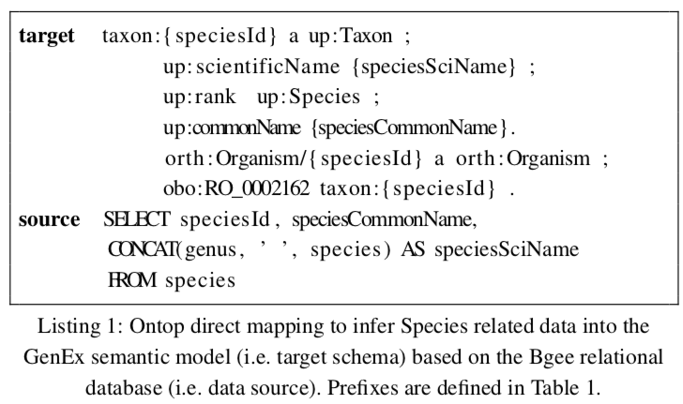

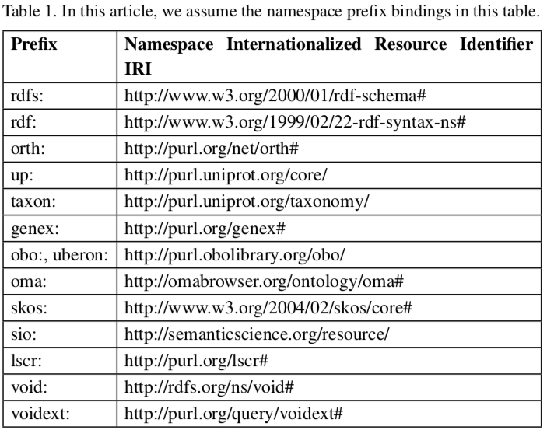

## Example SPARQL federated query across Bgee, OMA, UniProt

*What are the human genes which have a known association to glioblastoma (a type of brain cancer) and which furthermore have an orthologous gene expressed in the rat's brain?*

PREFIX rdfs: <http://www.w3.org/2000/01/rdf-schema#>

PREFIX obo: <http://purl.obolibrary.org/obo/>

PREFIX orth: <http://purl.org/net/orth#>

PREFIX sio: <http://semanticscience.org/resource/>

PREFIX taxon: <http://purl.uniprot.org/taxonomy/>

PREFIX up: <http://purl.uniprot.org/core/>

PREFIX lscr: <http://purl.org/lscr#>

PREFIX genex:<http://purl.org/genex#>

SELECT DISTINCT ?protein ?orthologous_protein_rat ?id WHERE {

SELECT * {

SERVICE <http://sparql.uniprot.org/sparql> {

SELECT ?protein WHERE {

?protein a up:Protein;

up:organism taxon:9606 ;

up:annotation ?annotation .

?annotation rdfs:comment ?annotation_text.

?annotation a up:Disease_Annotation.

FILTER CONTAINS (?annotation_text, "**glioblastoma**")

}}

SERVICE <https://sparql.omabrowser.org/sparql> {

SELECT ?orthologous_protein_rat ?protein ?id WHERE {

?protein_OMA a orth:Protein.

?orthologous_protein_rat a orth:Protein.

?cluster a orth:OrthologsCluster.

?cluster orth:hasHomologousMember ?node1.

?cluster orth:hasHomologousMember ?node2.

?node2 orth:hasHomologousMember* ?protein_OMA.

?node1 orth:hasHomologousMember* ?orthologous_protein_rat.

?orthologous_protein_rat orth:organism/obo:RO_0002162 taxon:10116.

?orthologous_protein_rat sio:SIO_010079/lscr:xrefEnsemblGene ?id.

?protein_OMA lscr:xrefUniprot ?protein.

FILTER(?node1 != ?node2)

}}

SERVICE <http://biosoda.expasy.org:8080/rdf4j-server/repositories/bgeelight> {

?gene genex:isExpressedIn ?anatEntity .

?anatEntity rdfs:label "brain".

?gene orth:organism ?org .

?org obo:RO_0002162 taxon:10116.

?gene lscr:xrefEnsemblGene ?id.

}}}

## RESULTS

The following table displays the results of executing the SPARQL query above, where:

* The first column, “***protein***”, shows UniProt human proteins with a known association with glioblastoma for which there exists an orthologous protein expressed in the rat’s brain. Clicking on any of the links in this column will redirect to the corresponding UniProt entry online.
* The second column, “***orthologous_protein_rat***”, shows the orthologous rat protein (for which there exists known expression in the brain according to data from Bgee)
* The third column, *“****id****”*, shows the Ensembl ID of the gene encoded by the rat protein (from column 2). Note that the ensemble ID (e.g. *ENSRNOG00000008839*) can be used in the Bgee search interface at <https://bgee.org/> for validating the results.

|  |  |  |
| --- | --- | --- |
| **protein** | **orthologous_protein_rat** | **id** |
| <http://purl.uniprot.org/uniprot/P37231> | <https://omabrowser.org/oma/info/RATNO15188> | <http://rdf.ebi.ac.uk/resource/ensembl/ENSRNOG00000008839> |
| <http://purl.uniprot.org/uniprot/P08922> | <https://omabrowser.org/oma/info/RATNO12308> | <http://rdf.ebi.ac.uk/resource/ensembl/ENSRNOG00000000406> |
| <http://purl.uniprot.org/uniprot/P68431> | <https://omabrowser.org/oma/info/RATNO09038> | <http://rdf.ebi.ac.uk/resource/ensembl/ENSRNOG00000053155> |
| <http://purl.uniprot.org/uniprot/P68431> | <https://omabrowser.org/oma/info/RATNO09042> | <http://rdf.ebi.ac.uk/resource/ensembl/ENSRNOG00000056281> |
| <http://purl.uniprot.org/uniprot/P68431> | <https://omabrowser.org/oma/info/RATNO11352> | <http://rdf.ebi.ac.uk/resource/ensembl/ENSRNOG00000060366> |
| <http://purl.uniprot.org/uniprot/Q14956> | <https://omabrowser.org/oma/info/RATNO14717> | <http://rdf.ebi.ac.uk/resource/ensembl/ENSRNOG00000008816> |
| <http://purl.uniprot.org/uniprot/P84243> | <https://omabrowser.org/oma/info/RATNO18582> | <http://rdf.ebi.ac.uk/resource/ensembl/ENSRNOG00000032401> |
| <http://purl.uniprot.org/uniprot/P84243> | <https://omabrowser.org/oma/info/RATNO06508> | <http://rdf.ebi.ac.uk/resource/ensembl/ENSRNOG00000003220> |
| <http://purl.uniprot.org/uniprot/O75140> | <https://omabrowser.org/oma/info/RATNO07117> | <http://rdf.ebi.ac.uk/resource/ensembl/ENSRNOG00000018144> |
| <http://purl.uniprot.org/uniprot/Q12980> | <https://omabrowser.org/oma/info/RATNO03263> | <http://rdf.ebi.ac.uk/resource/ensembl/ENSRNOG00000020541> |
| <http://purl.uniprot.org/uniprot/Q8WTW4> | <https://omabrowser.org/oma/info/RATNO20234> | <http://rdf.ebi.ac.uk/resource/ensembl/ENSRNOG00000021660> |
| <http://purl.uniprot.org/uniprot/Q9BZH6> | <https://omabrowser.org/oma/info/RATNO02052> | <http://rdf.ebi.ac.uk/resource/ensembl/ENSRNOG00000020430> |
| <http://purl.uniprot.org/uniprot/Q9HD26> | <https://omabrowser.org/oma/info/RATNO12311> | <http://rdf.ebi.ac.uk/resource/ensembl/ENSRNOG00000000408> |
| <http://purl.uniprot.org/uniprot/Q9Y243> | <https://omabrowser.org/oma/info/RATNO06482> | <http://rdf.ebi.ac.uk/resource/ensembl/ENSRNOG00000021497> |
| <http://purl.uniprot.org/uniprot/Q9UM73> | <https://omabrowser.org/oma/info/RATNO17047> | <http://rdf.ebi.ac.uk/resource/ensembl/ENSRNOG00000008683> |

## Example relational-to-RDF mappings

The following figure (see Fig 2 in paper) illustrates graphically an example of exposing relational data from Bgee (shown in the bottom half of the figure, the relational model) in a virtual RDF graph (a fraction of the ontology and 2 instances are shown in the upper half of the figure, the RDF model).

The orange rectangles in the OBDA mappings layer (in the center of the figure) represent the “source” fragments (a simplified SQL statement) of a relational-to-RDF mapping, while the blue rectangles illustrate the “target” (resulting RDF triples). For readability purposes, we only included 3 sample mappings in this figure. However, the full set of OBDA mappings employed with the Bgee relational data is available in our github repository at <https://github.com/biosoda/bioquery/tree/master/Bgee_OBDA_mappings> .

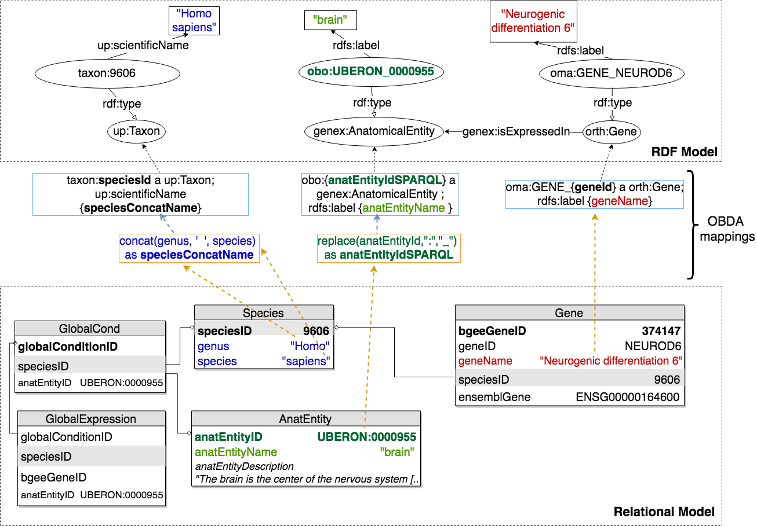

The complete list of federated queries is available in our template-based search interface at [http://biosoda.expasy.org](http://biosoda.expasy.org/).

## Information available in Bgee, OMA and UniProt

In the following table we provide an overview of the type of information available in Bgee, OMA and UniProt, both in the original representation (relational database for Bgee and HDF5 for OMA), as well as in RDF. More precisely, an “x” represents information available; an added “+” symbolizes information available **in RDF**; and “o” represents a link to other databases (e.g. OMA homologous groups).

|  |  |  |  |
| --- | --- | --- | --- |
| **Information** | **Bgee** | **OMA** | **UniProt** |
| Gene Ontology annotations | x | x | x+ |
| Cross-references | x+ | x+ | x+ |
| Family and domain |  | x | x+ |
| Local synteny |  | x |  |
| Pairwise homologous genes/proteins |  | x+ |  |
| Homologous groups of genes/proteins | o | x+ | o |
| Hierarchical Orthologous Group (HOG) |  | x+ | o |
| Gene expression | x+ |  | o |
| Absence of gene expression | x |  |  |
| Anatomical entity annotations (UBERON) | x+ |  |  |
| Developmental stage annotations | x+ |  |  |
| Species taxonomy (NCBI identifiers) | x+ | x+ | x+ (fully) |
| Gene and/or protein names | x+ | x+ | x+ |
| Subcellular location (including GO annotation) |  | x | x+ |
| Sequences |  | x | x+ |
| Post-translational modifications and/or processing events |  |  | x+ |
| Protein structures (quaternary, tertiary and secondary) |  |  | x+ |
| Similar proteins based on their membership in UniProt Reference Clusters (UniRef). |  |  | x+ |